Joshua Chapter 19
1 The second lot fell to Shimon. The portion of the tribe of the Shimonites, by their clans, lay inside the portion of the Judahites. 2 Their portion comprised: Beer-sheva, Sheva, Moladah, 3 Chatzar-shual, Balah, Etzem, 4 Eltolad, B’tul, Chormah, 5 Tziklag, Bet-marcavot, Chatzar-susah, 6 Bet-l’vaot, and Sharuhcen—13 towns, with their villages. 7 Ayin, Rimmon, Ehter, and Ashan: 4 towns, with their villages—8 together with all the villages in the vicinity of those towns, down to Ba-alat-beer [and] Ramat-negev. That was the portion of the tribe of the Shimonites, by their clans. 9 The portion of the Shimonites was part of the territory of the Judahites; since the share of the Judahites was larger than they needed, the Shimonites received a portion inside their portion.
10 The third lot emerged for the Zevulunites, by their clans. The boundary of their portion: Starting at Sarid, 11 their [southern] boundary ascended westward to Maralah, touching Dabbeshet and touching the wadi alongside Yokneam. 12 And it also ran from Sarid along the eastern side, where the sun rises, past the territory of Kislot-tavor and on to Dav’rat and ascended to Yafia. 13 From there it ran [back] to the east, toward the sunrise, to Gat-chefer, to Et-katzin, and on to Rimmon, where it curved to Neah. 14 Then it turned—that is, the boundary on the north—to Channaton. Its extreme limits [in the northeast corner] were the Valley of Yiftach-el, 15 Kattat, Nahalal, Shimron, Yidalah, and Bet-lechem: 12 towns, with their villages. 16 That was the portion of the Zevulunites by their clans—those towns, with their villages.
17 The fourth lot fell to Yisachar, the Yisacharites by their clans. 18 Their territory comprised: Yizrael, K’sullot, Shunem, 19 Chafaraim, Shion, Anacharat, 20 Rab-beet, Kishion, Evetz, 21 Remet, En-gannim, En-chaddah, and Bet-patzetz. 22 The boundary touched Tabor, Shachatzimah, and Bet-shemesh; and their boundary ran to the Jordan: 16 towns, with their villages. 23 That was the portion of the tribe of the Yisacharites, by their clans—the towns with their villages.
24 The ﬁfth lot fell to the tribe of the Asherites, by their clans. 25 Their [southern] boundary ran along Chelkat, Chali, Beten, Achshaf, 26 Allam-melech, Amad, and Mishal; and it touched Carmel on the west, and Shichor-livnat. 27 It also ran [from Chelkat] along the east side to Bet-dagon, and touched Zevulun and the Valley of Yiftach-el to the north, [as also] Bet-emek and N’iel; then it ran to Cabul on the north, 28 Evron, Rechov, Chammon, and Kanah, up to Great Sidon. 29 The boundary turned to Ramah and on to the fortiﬁed city of Tyre; then the boundary turned to Chosah and it ran on westward to Mechevel, Achziv, 30 Ummah, Afek, and Rechov: 22 towns, with their villages. 31 That was the portion of the tribe of the Asherites, by their clans—those towns, with their villages.
32 The sixth lot fell to the Naftalites, the Naftalites by their clans. 33 Their boundary ran from Chelef, Elon-b’tza-ananim, Adami-nekev, and Yavn’el to Lakkum, and it ended at the Jordan. 34 The boundary then turned westward to Aznot-tavor and ran from there to Chukok. It touched Zevulun on the south, and it touched Asher on the west, and Judah at the Jordan on the east. 35 Its fortiﬁed towns were Tziddim, Tzer, Chammat, Rakkat, Kineret, 36 Adamah, Ramah, Chatzor, 37 Kedesh, Edrei, En-chatzor, 38 Yiron, Migdal-el, Chorem, Bet-anat, and Bet-shemesh: 19 towns, with their villages. 39 That was the portion of the tribe of the Naftalites, by their clans—the towns, with their villages.
40 The seventh lot fell to the tribe of the Danites, by their clans. 41 Their allotted territory comprised: Tzorah, Eshtaol, Ir-shemesh, 42 Sha-a-labbin, Ayaalon, Yitlah, 43 Elon, Timnah, Ekron, 44 Elt’keh, Gib’ton, Baalat, 45 Yehud, Benie-b’rak, Gat-rimmon, 46 Me-yarkon, and Rakkon, at the border near Yafo. 47 But the ter-ritory of the Danites slipped from their grasp. So the Danites migrated and made war on Leshem [or La-ish, as in Judges 18.7]. They captured it and put it to the sword; they took possession of it and settled in it. And they changed the name of Leshem to Dan, after their ancestor Dan. 48 That was the portion of the tribe of the Danites, by their clans—those towns, with their villages.
49 When they had ﬁnished allotting the land by its boundaries, the Israelites gave a portion in their midst to Joshua son of Nun. 50 At the command of the Lord, they gave him the town that he asked for, Timnat-serach in the hill country of Efraim; he fortiﬁed the town and settled in it.
51 These are the portions assigned by lot to the tribes of Israel by the priest Eleazar, Joshua son of Nun, and the heads of the ancestral houses, before the Lord at Shiloh, at the entrance of the Tent of Meeting.

Joshua Chapter 20
1 When they had ﬁnished dividing the land, 1the Lord said to Joshua:
2 “Speak to the Israelites: Designate the cities of refuge—about which I commanded you through Moses—
3 to which a manslayer who kills a person by mistake, unintentionally, may ﬂee. They shall serve you as a refuge from the blood avenger.
4 He shall ﬂee to one of those cities, present himself at the entrance to the city gate, and plead his case before the elders of that city; and they shall admit him into the city and give him a place in which to live among them.
5 Should the blood avenger pursue him, they shall not hand the manslayer over to him, since he killed the other person without intent and had not been his enemy in the past.
6 He shall live in that city until he can stand trial before the assembly, [and remain there] until the death of the high priest who is in oﬃce at that time. Thereafter, the manslayer may go back to his home in his own town, to the town from which he ﬂed.”
7 So they set aside Kedesh in the hill country of Naftali in Galilee, Shechem in the hill country of Efraim, and Kiriat-arba—that is, Khevron—in the hill country of Judah.
8 And across the Jordan, east of Jericho, they assigned Betzer in the wilderness, in the Tableland, from the tribe of Reuven; Ramot in Gil’ad from the tribe of Gad; and Golan in Bashan from the tribe of Menasheh.
9 Those were the towns designated for all the Israelites and fo raliens residing among them, to which anyone who killed a person unintentionally might ﬂee, and not die by the hand of the blood avenger before standing trial by the assembly.

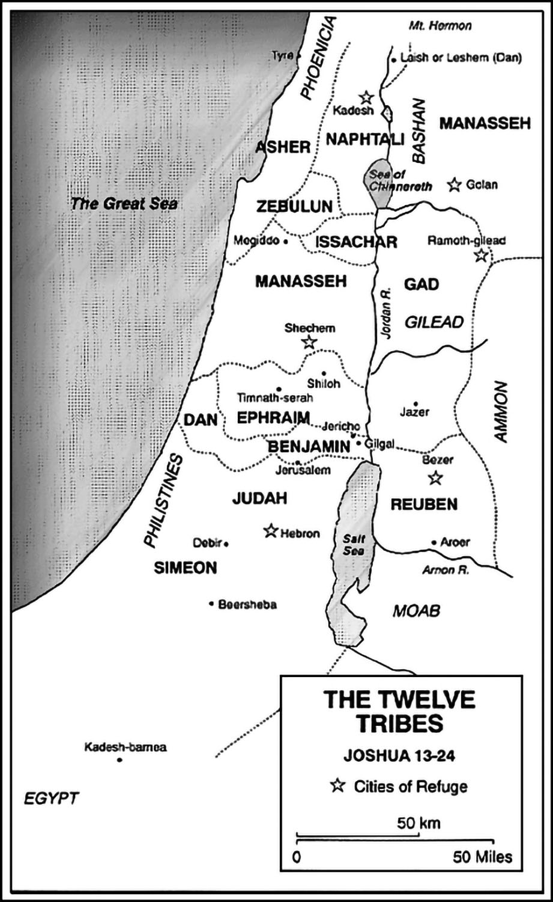
Joshua Chapter 21
1 The heads of the ancestral houses of the Levites approached the priest Eleazar, Joshua son of Nun, and the heads of the ancestral houses of the Israelite tribes,
2 and spoke to them at Shiloh in the land of Canaan, as follows: “The Lord commanded through Moses that we be given towns to live in, along with their pastures for our livestock.”
3 So the Israelites, in accordance with the Lord’s command, assigned to the Levites, out of their own portions, the following towns with their pastures:
4 The [ﬁrst] lot among the Levites fell to the Kohatite clans. To the descendants of the priest Aaron, there fell by lot 13 towns from the tribe of Judah, the tribe of Shimon, and the tribe of Benjamin;
5 and to the remaining Kohatites [there fell] by lot 10 towns from the clans of the tribe of Efraim, the tribe of Dan, and the half-tribe of Menasheh.
6 To the Gershonites [there fell] by lot 13 towns from the clans of the tribe of Yisachar, the tribe of Asher, the tribe of Naftali, and the half-tribe of Menasheh in Bashan.
7 [And] to the Merarites, by their clans—12 towns from the tribe of Reuven, the tribe of Gad, and the tribe of Zevulun.
8 The Israelites assigned those towns with their pastures by lot to the Levites—as the Lord had commanded through Moses.
9 From the tribe of the Judahites and the tribe of the Shimonites were assigned the following towns, which will be listed by name;
10 they went to the descendants of Aaron among the Kohatite clans of the Levites, for the ﬁrst lot had fallen to them.
11 To them were assigned in the hill country of Judah Kiriat-arba—that is, Khevron—together with the pastures around it. [Arba was] the father of the Anokites [or perhaps Anakites].
12 They gave the ﬁelds and the villages of the town to Calev ben Yefuneh as his holding.
13 But to the descendants of Aaron the priest they assigned Khevron—the city of refuge for manslayers—together with its pastures, Livnah with its pastures,
14 Yattir with its pastures, Esht’moa with its pastures,
15 Cholon with its pastures, D’vir with its pastures,
16 Ayin with its pastures, Yuttah with its pastures, and Bet-shemesh with its pastures—9 towns from those two tribes.
17 And from the tribe of Benjamin: Giv’on with its pastures, Geva with its pastures,
18 Anatot with its pastures, and Almon with its pastures—4 towns.
19 All the towns of the descendants of the priest Aaron, 13 towns with their pastures.
20 As for the other clans of the Kohatites, the remaining Levites descended from Kohat, the towns in their lot were: From the tribe of Efraim
21 they were given, in the hill country of Efraim, Shechem—the city of refuge for manslayers—with its pastures, Gezer with its pastures,
22 Kivtzaim with its pastures, and Bet-vhoron with its pastures—4 towns.
23 From the tribe of Dan, Elt’ke with its pastures, Gibb’ton with its pastures,
24 Ayaalon with its pastures, and Gat-rimmon with its pastures—4 towns.
25 And from the half-tribe of Menasheh, Taanach with its pastures, and Gat-rimmon with its pastures—2 towns.
26 All the towns for the remaining clans of the Kohatites came to 10, with their pastures.
27 To the Gershonites of the levitical clans: From the half-tribe of Menasheh, Golan in Bashan—the city of refuge for manslayers— with its pastures, and B’eshterah with its pastures—2 towns.
28 From the tribe of Yisachar: Kishyon with its pastures, Dovrat with its pastures,
29 Yarmut with its pastures, and En-gannim with its pastures—4 towns.
30 From the tribe of Asher: Mishal with its pastures, Avdon with its pastures,
31 Chelkat with its pastures, and Rechov with its pastures—4 towns.
32 From the tribe of Naftali, Kedesh in Galilee—the city of refuge for manslayers—with its pastures, Chammot-dor with its pastures, and Kartan with its pastures—3 towns.
33 All the towns of the Gershonites, by their clans, came to 13 towns, with their pastures.
34 To the remaining Levites, the clans of the Merarites: From the tribe of Zevulun, Yokneam with its pastures, Kartah with its pastures,
35 Dimnah with its pastures, and Nahalal with its pastures—4 towns.
36 From the tribe of Gad, Ramot in Gil’ad—the city of refuge for manslayers—with its pastures, Machanaim with its pastures,
37 Cheshbon with its pastures, and Yazer with its pastures—4 towns in all.
38 All the towns which went by lot to the Merarites, by their clans—the rest of the Levitical clans—came to 12 towns.
39 All the towns of the Levites within the holdings of the Israelites came to 48 towns, with their pastures.
40 Thus those towns were assigned, every town with its surrounding pasture; and so it was with all those towns.
41 The Lord gave to Israel the whole country which He had sworn to their fathers that He would assign to them; they took possession of it and settled in it.
42 The Lord gave them rest on all sides, just as He had promised to their fathers on oath. Not one man of all their enemies withstood them; the Lord delivered all their enemies into their hands.
43 Not one of the good things which the Lord had promised to the House of Israel was lacking. Everything was fulﬁlled.

